**Part 1:**

Step 1:

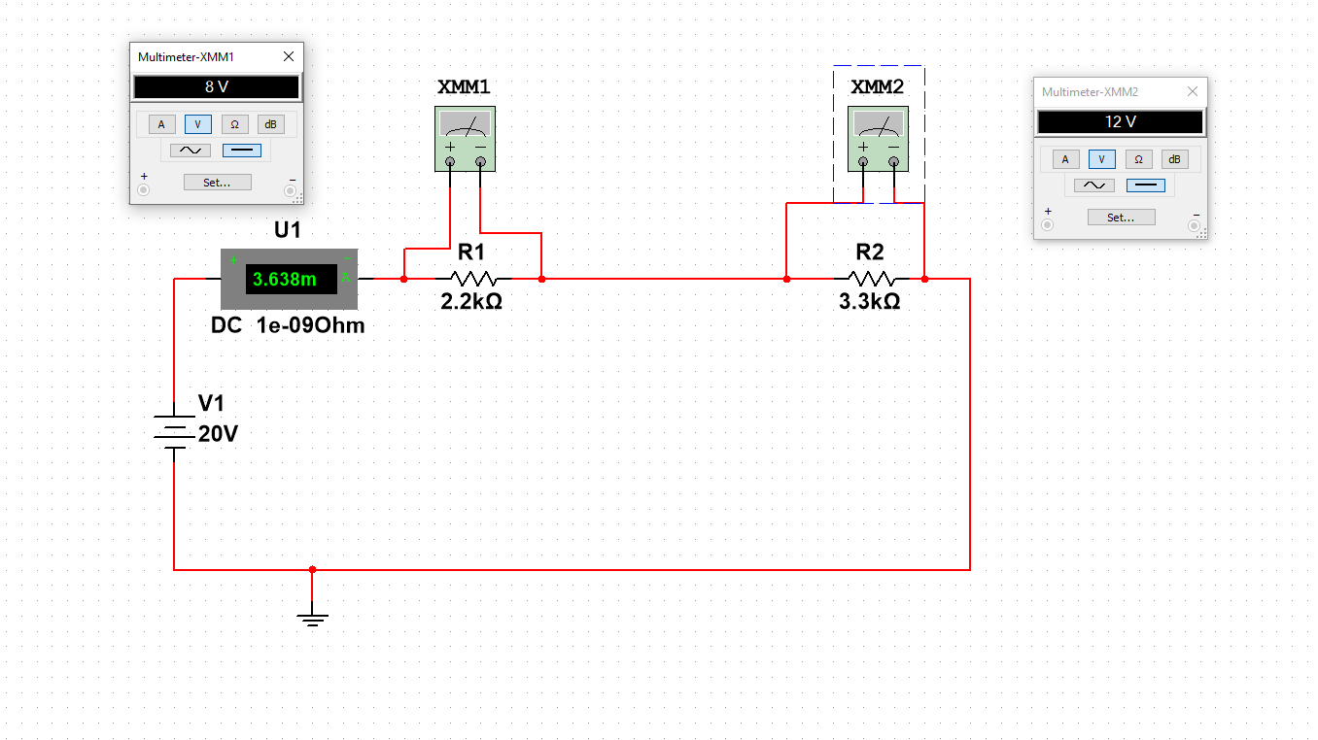

Step 2:

We get a current of 3.638 mA, V1 = 8V, V2 = 12v, R1 = 2.2kohm, R2 = 3.3kohm

Step 3:

|  |  |  |  |
| --- | --- | --- | --- |
|  | Measured | Calculated | Percentage difference |
| Current | 3.638 mA | 3.636 mA | 0.055% |
| V1 | 8 V | 7.9992 | 0.01% |
| V2 | 12 V | 11.9988 | 0.01% |

Step 4:

V1:V2 = ⅔.

R1:R2 = ⅔.

The ratios of V1:V2 and R1:R2 are the same.

Step 5:

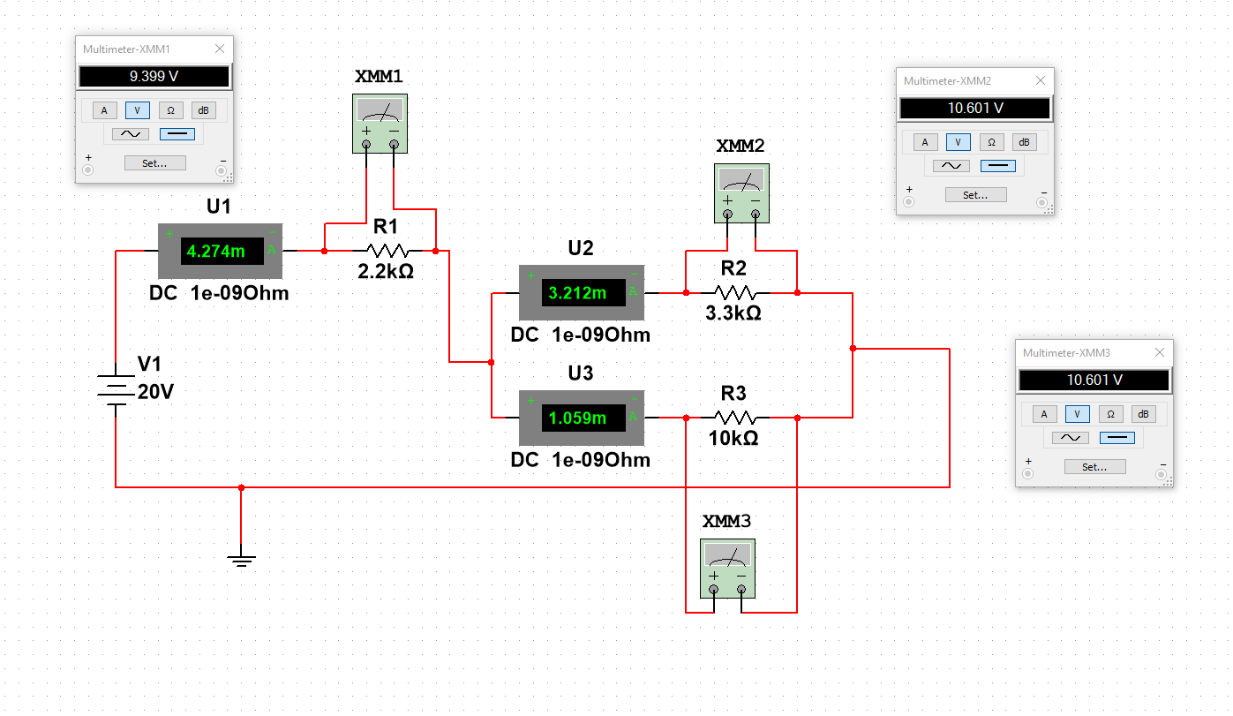

I1 = 4.274 mA, I2 = 3.212 mA, I3 = 1.059 mA, R3 = 10kohm, V1 = 9.399V, V2 = 10.601V, V3 = 10.601V

Step 6:

|  |  |  |  |
| --- | --- | --- | --- |
|  | Measured | Calculated | Percentage difference |
| I1 | 4.274 mA | 4.272 mA | 0.0468% |
| I2 | 3.212 mA | 3.212 mA | 0% |
| I3 | 1.059 mA | 1.060 mA | -0.09% |
| V1 | 9.399 V | 9.398 V | 0.01% |
| V2 | 10.601 V | 10.600 V | 0.009% |
| V3 | 10.601 V | 10.600 V | 0.009% |

Step 7:

Req = ((1/3.3) + (1/10)) ^ -1 = 2.481

Req = 2.481 KOhm

Step 8:

I2:I3 = 3.03

R2:R3 = 0.33

I2:I3 and R2:R3 are inversely related, where 0.33^-1 = 3.03, and 3.03^-1 = 0.33.

Step 9:

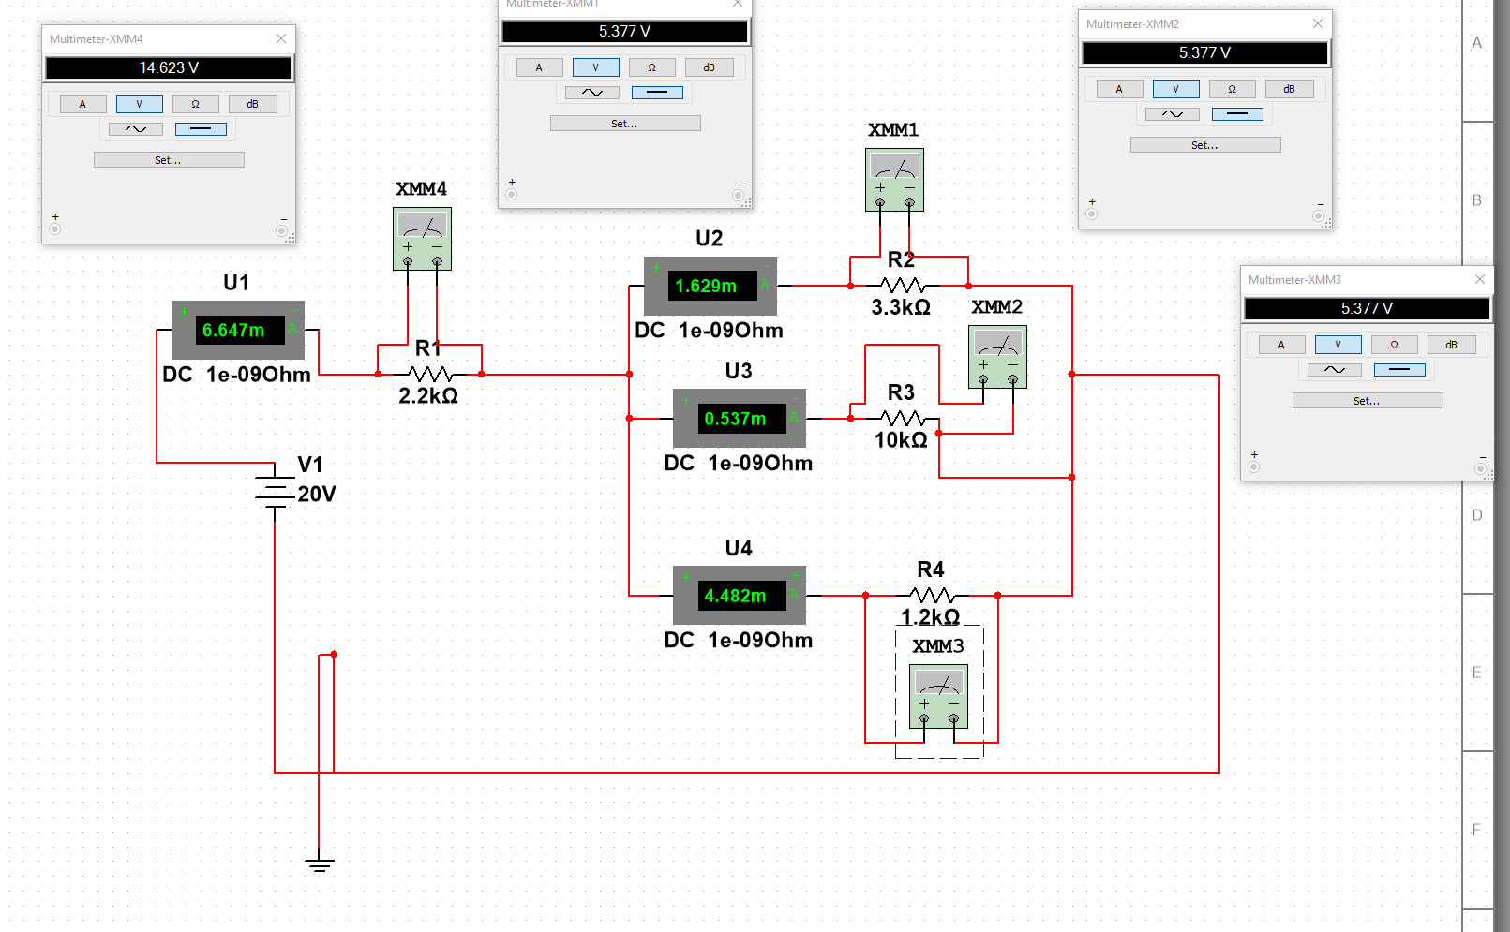

Step 10:

I1 = 6.647 mA, I2 = 1.629mA, I3 = 0.537mA, I4 = 4.482 mA, V1 = 14.623 V, V2 = 5.377 V, V3 = 5.377V, V4 = 5.377V.

|  |  |  |  |
| --- | --- | --- | --- |
|  | Measured | Calculated | Percentage difference |
| I1 | 6.647 mA | 6.646 mA | 0.015% |
| I2 | 1.629 mA | 1.629 mA | 0% |
| I3 | 0.537 mA | 0.538 mA | -0.186% |
| I4 | 4.482 mA | 4.480 mA | 0.0447% |
| V1 | 14.623 V | 14.621 V | 0.0137% |
| V2 | 5.377 V | 5.376 | 0.0186% |
| V3 | 5.377 V | 5.38 | -0.0558% |
| V4 | 5.377 V | 5.376 | 0.0186% |

Req = 0.809 KOhm

The current I1 is equal to the sum of I2, I3 and I4.

**Part 2:**

Step 1:

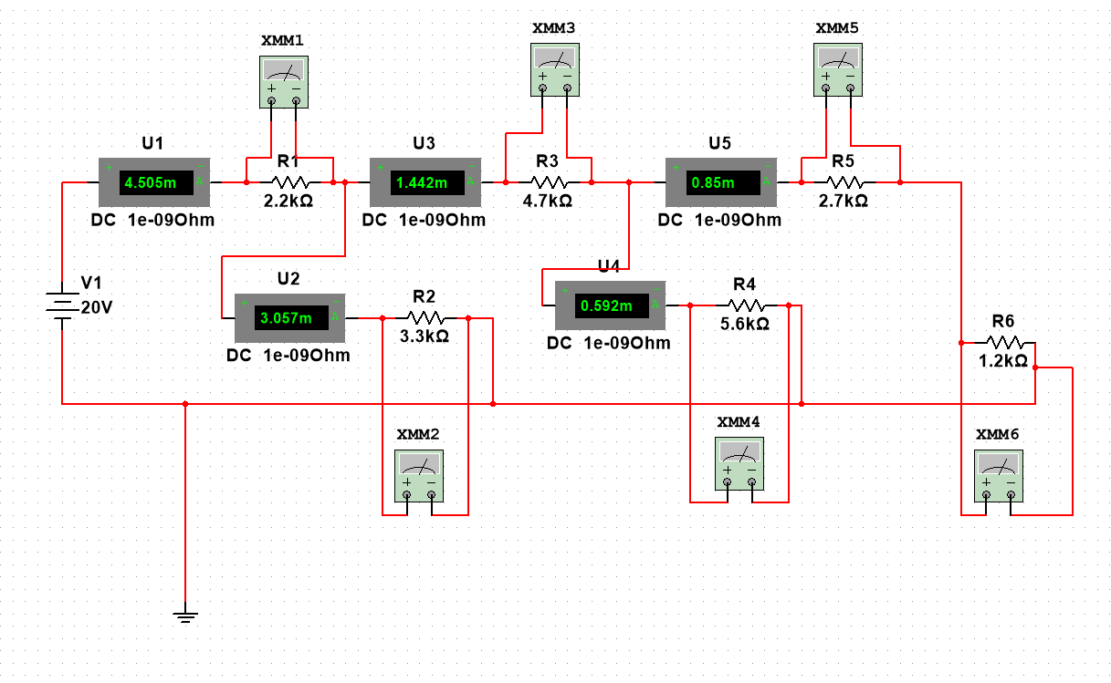

V = 20 V

Step 2:

|  |  |  |  |
| --- | --- | --- | --- |
|  | Measured | Calculated | Percentage difference |
| I1 | 4.505 mA | 4.502 mA | 0.066637% |
| I2 | 3.057 mA | 3.060 mA | -0.09804% |
| I3 | 1.442 mA | 1.442 mA | 0% |
| I4 | 0.592 mA | 0.583 mA | 1.543739% |
| I5 | 0.85 mA | 0.859 mA | -1.04773% |
| V1 | 9.907 V | 9.904 V | 0.030291% |
| V2 | 10.093 V | 10.098 V | -0.04951% |
| V3 | 6.777 V | 6.7774 V | -0.0059% |
| V4 | 3.316 V | 3.2648 V | 1.568243% |
| V5 | 2.295 V | 2.3193 V | -1.04773% |
| V6 | 1.02 V | 1.0308 V | -1.04773% |

Step 3:

I1 = I2 + I3

I3 = I4 + I5

Step 4:

20 = I1R1 + I2R2

20 = I1R1 + I3R3 + I4R4

20 = I1R1 + I3R3 + I5(R5 + R6)

I2R2 = I3R3 + I4R4

I4R4 = I5(R5 + R6)

Step 5:

R56 = 2.7 + 1.2 = 3.9

R456 = ((1/3.9) + (1/5.6))^ -1 = 2.299

R3456 = 2.299 + 4.7 = 6.999

R23456 = ((1/6.999) + (1/3.3))^-1 = 2.243

Req = 2.243 + 2.2 = 4.443

Req= 4.443 kOhm

Step 6:

V = IR

V = 20 V

I1 = 4.505 mA

R = (20)/(4.505 * 10^-3) = 4439.512 Ohms = 4.440 kOhms

Percentage difference = (4.443 - 4.44)/(4.44) * 100 = 0.0676%

Step 7:

If R6 is unknown, we can use Ohm’s law to solve for the equivalent resistance, based on the fact that we already know the Voltage and the measured I1. We can then work backwards in order to find R6, since we know all of the other values. We can solve for I5 using the current junction rule, and solve for R6 using the KVL equations.